QUIZLET Review Rubric
*(Website/Mobile App/Web 2.0) (Updated 3.10.2016)
Criteria | Score  (out of 5)
Educational Value:  Does the QUIZLET have educational value? How much does the resource contribute to learning? Is it worth to sign up and create an account with this QUIZLET for Teachers or Students? | 5
Creativity, Fun & Interactivity:  Is the QUIZLET creative and original? Does the QUIZLET use innovative ways to engage users? Does the resource encourage creative thinking? Is the QUIZLET interactive? Is it fun to use the QUIZLET ? | 5
Intuitive Interface:  Does the interface is simple and intuitive? Does the QUIZLET have user-friendly menus, buttons, guides, controls etc.? | 5
Visual Design & Optimization:  Does the QUIZLET have a great looking interface and other design elements (color choice, graphics etc)? | 3
Stability & Promises:  Does the QUIZLET work all the time? Does it crash or does it have bugs? Does the QUIZLET meet its promises as claimed in its description? | 5
Value for Price:  Is the QUIZLET free or paid? Does it have a good value for the price? | 5
Editor’s Score: (Average) | 5

Name of the Reviewer:
Nihat Celik
Name of the Resource Reviewed:
QUIZLET App for Android
What is this Resource?
Mobile App
Link to the resource:
Android App
https://quizlet.com/
Price:
Free.
Platforms: (PC, Mac, Android, IOS, etc.)
Android version is reviewed. The Quizlet is available for all platforms.
Appropriate for Grade Levels: (K-16)
Quizlet is appropriate for K-12th grades and College students.
Editor’s Score: (Average of all scores)
4.66
Main Article: (Description of the resource/tool? What does the resource do? How does it work? How did you like it? What are the advantages and limitations?)
The Quizlet Android app is not just for students and teachers, but for anyone engaged in learning for business, pleasure, and happy hour trivia competitions. It is a smart, sophisticated, and surprisingly simple tool to research, share, and study flashcards – called sets in Quizlet – on virtually any subject, concept, and strategy at any level. With topics ranging from chemistry and finance to learning the alphabet and destroying an opponent in chess, the impressive quantity and quality of study tools are smartly organized in the Quizlet Android app.
The sign-in process is straightforward. A log-in may be created with date of birth, username, password, and email address. Social authorizations of Google and Facebook are also options to create an account. The social connections allow collaboration for study groups, and some teachers and students have created classes to add sets relevant to in-class material. It is helpful to be aware social sharing is not a requirement to access tools and functions. The Quizlet Android app also syncs with a quizlet.com account, so all devices have access to history, favorites, and saved sets.

Educational uses and applications for Education/classroom: (How could this app be used for education? Specific activities, examples)
It is not just teachers that can share resources with their children. The children can share study sets with each other. A nice plenary activity is to simply ask the class to create their own set of questions and answers based on the content of the lesson. They can then share them quickly and easily via the user name search function. This not only is a fun activity to offer up but it also involves some higher level learning. Children will really have to think about their subject knowledge if they wish to catch out other members of the class.
Pros/Advantages: (Short sentences, brief information)
Intuitive interface and flexible review features bring the best of paper flashcards to convenient digital form.
Cons/Disadvantages: (Short sentences, brief information)
Features for uploading and reviewing flashcard sets are limited on the app and better supported on the Quizlet website.
Summary:
Quizlet is a free website providing learning tools for students, including flashcards, study and game modes. It was created by high school sophomore Andrew Sutherland in 2005 and now contains over 400 million study sets. All of the material is user-generated.
Tags or Keywords:
Quizlet, Android, Android App Review
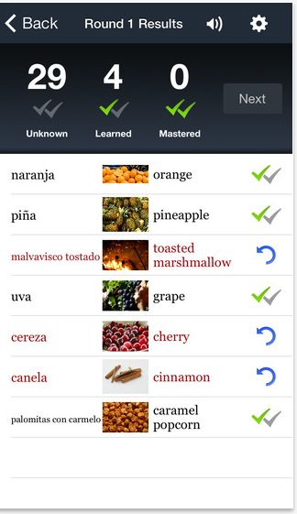
ATTACH PICTURES: (Logo or screenshots)

